STEP 5 – MESH - CFS3 SDK tools ERS2TIFF & TIIF2MSH
5.0-) It is time to get data for MESH CFS3 SDK tools. To do this, open the RAW.bil file on Global Mapper, RAW.ERS on Notepad and CFS3_Math. xls on Excel.
a-) Check the bounds of map in pixels on RAW.ERS file. The map have 768 x 768 pixels. (Remember that number must be multiple of 256). Rename the CellType to Signed16BitInteger (the ers2tiff tool do not accept Unsigned16BitInteger). Close the RAW.ers file.
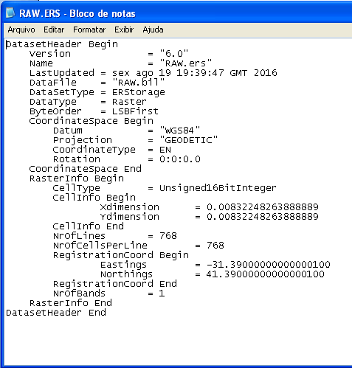
CellType = Signed16BitInteger
b-) On CFS3_Math.xls, select the cells at Theater edge dimension in pixels (Ref. Table) that corresponds with your map size. Also select the left cell. Fill the selected cells with green like following image.
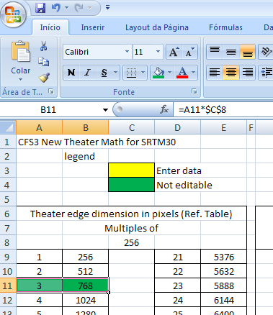
The number 3 on cell A11, is a ERS2TIFF tool parameter. It is a multiple of 256 to get 768. (256x3 = 768).
c-) On GM, we need to get the bounds of map in geographic coordinates: Menu FILE – EXPORT – EXPORT ELEVATION GRID FORMAT… (Do not export, only check export bounds on Export dialog window). Use these values on yellow cells on CFS3_Math - Center of the theater. CANCEL the BIL/BIP/BSQ Export Options dialog window.
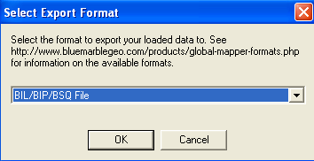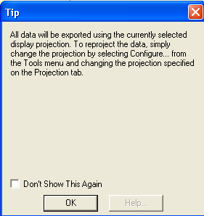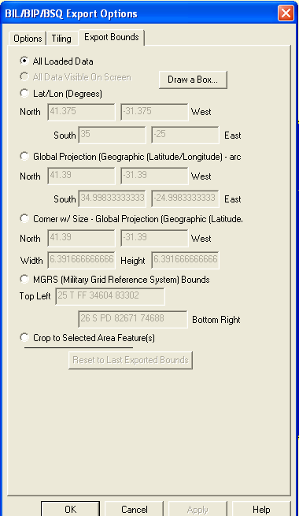
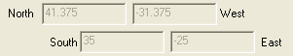
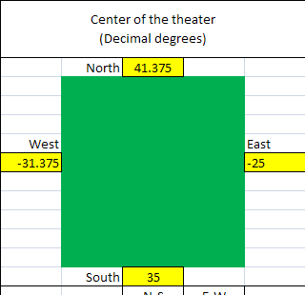
TIP: Note that map bounds is not the same of STEP 1.3 (STEP1 FILE). It´s because, when one small selection was made from large map size, GM make adjustments on small selection. It´s normal.
The CFS3_math calculates a theater center point. It´s an ERS2TIFF tool parameter. Click on METADATA… button.

d-) Back to GM. Getting max height of the map: Menu TOOLS – CONTROL CENTER
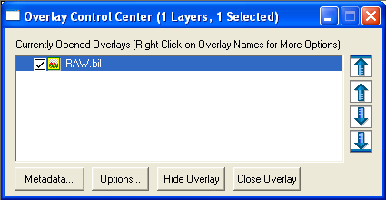

Get the map max elevation and edit the value on CFS3_Math with it. Close GM. 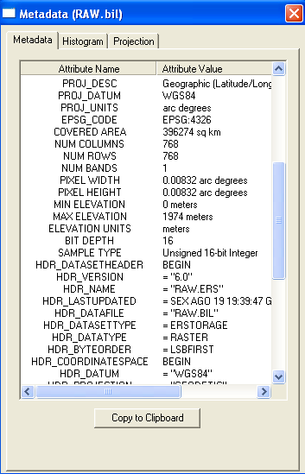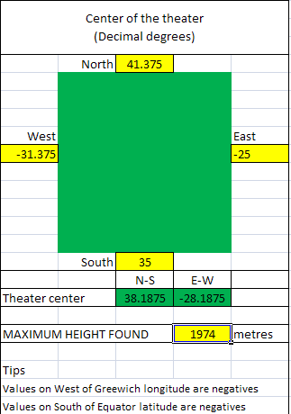

e-) If you want, you can modify the prefix parameter for TIFF2MSH tool. If you made a totally new cfs3 installation for your new theater, you don´t need to modify the prefix. Use the same cfs3 original prefix: CFS3Europe. Edit the value of Pixel Dim with that showed on step 5.0.b. (the edge size in pixels on map - 768).
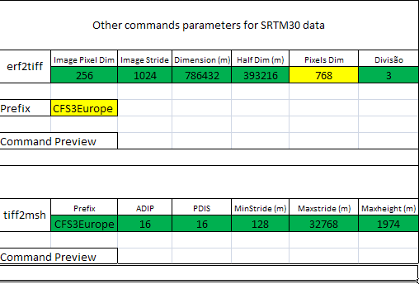

Now, all parameters for ERS2TIFF and TIFF2MSH are ready. Let´s go…

f-) On Command Preview for ers2tiff tool and tiff2msh tool, write the command using the parameters found.
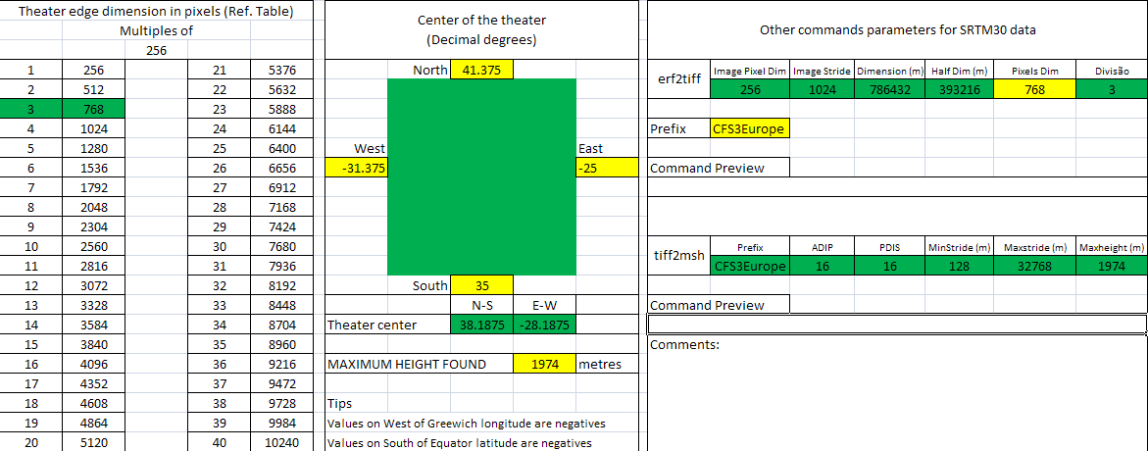

ers2tiff *.ers N38.1875 W28.1875 256 1024 1974 CFS3Europe -393216 -393216 3 3
tiff2msh CFS3Europe 16 16 128 32768 1974
TIP: Read the CFS3 SDK docs to understand what are all parameters.

Save the CFS3_Math.

5.1-) Check your working directory. For Terrain MESH, you will need the RAW.ers and RAW.bil files, generated on STEP 1.
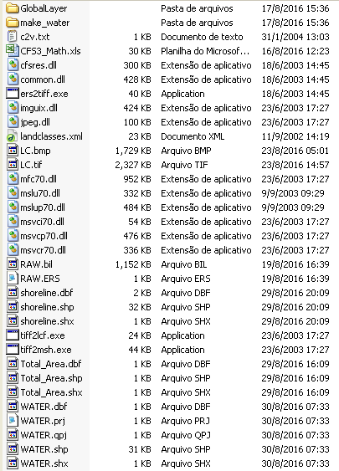

a-) Rename the file RAW.bil to RAW (eliminate the extension .bil).
b-) Start your command line prompt window and access your working dir with DOS commands:
cd\ - Send the prompt to the root dir.
cd cfs3t – To open the working dir .
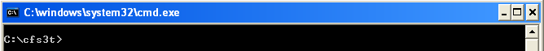

c-) Copy the ERS2TIFF command on CFS3_Math and paste at command line window by pressing right mouse button. On a popup menu, choose PASTE. Press ENTER and see the generated TIFF files on working dir.
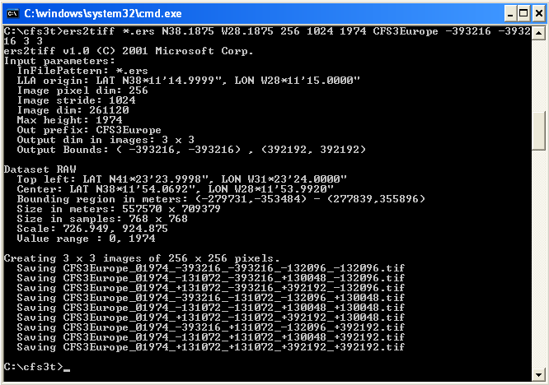
d-) BEFORE CONTINUE, CHECK THE TIFF FILES WITH IRFANVIEW. Some files are complete black areas (ocean) but you must see the land areas in grayscale shape similar to the BIL file. Use ZOOM and ARROWS buttons to see the small 256x256 files better.
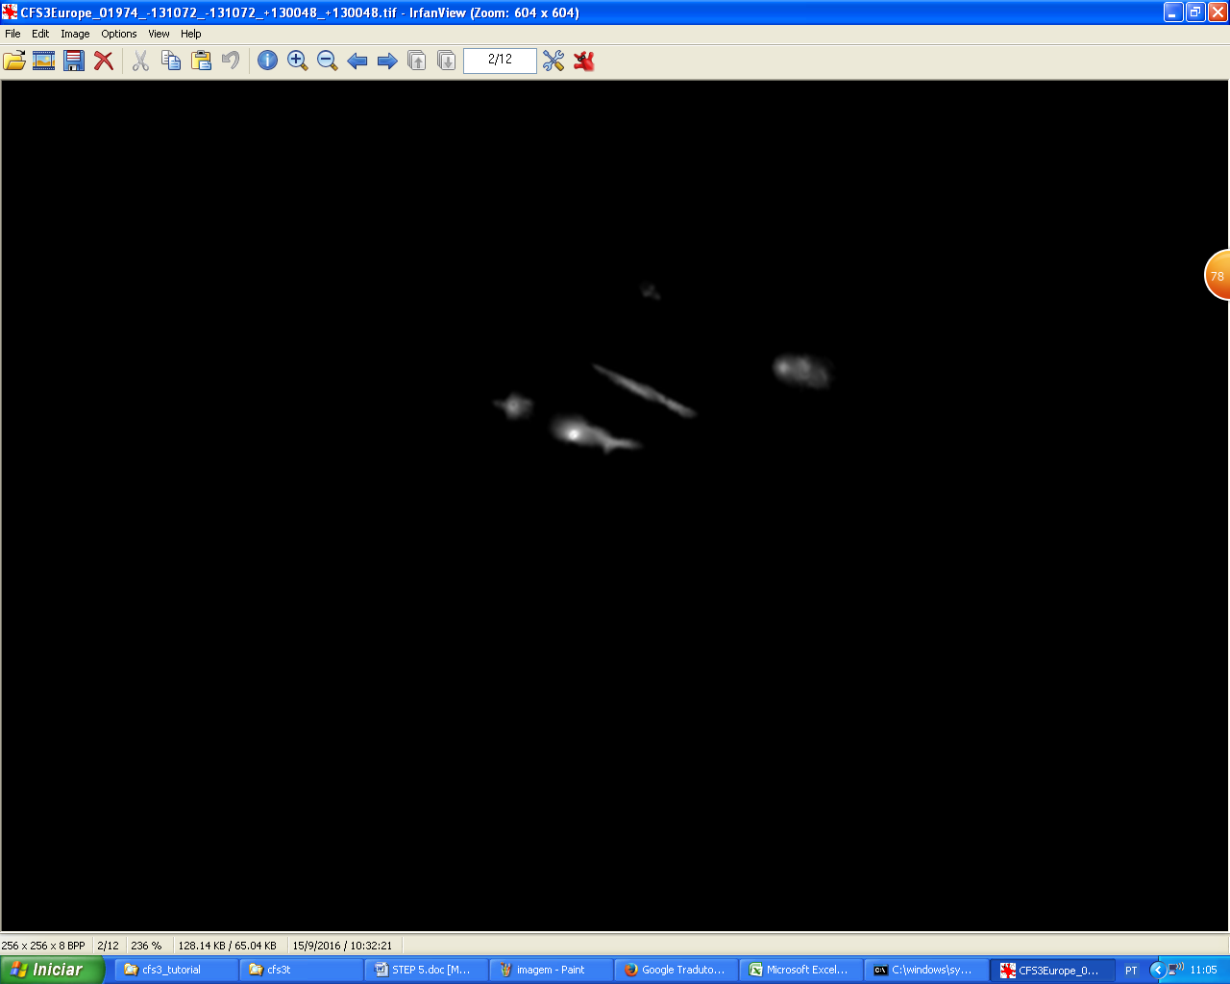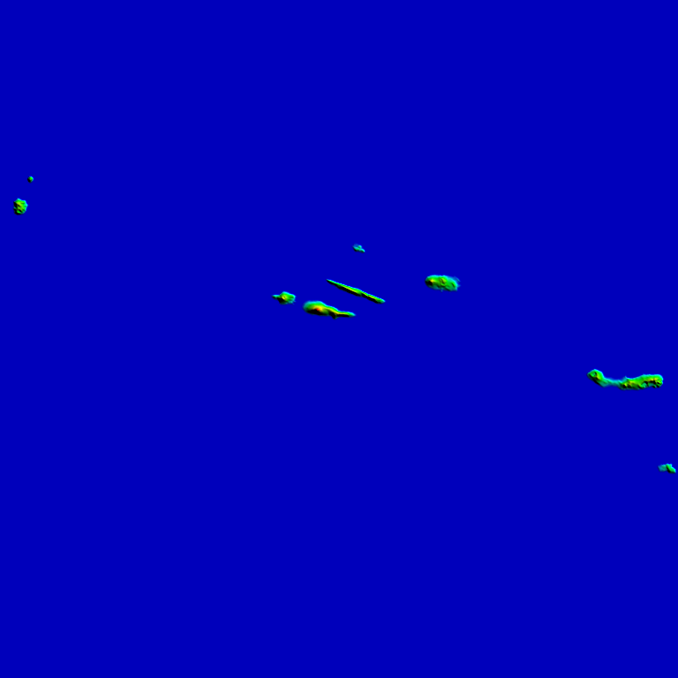
If you get a wrong TIFF files, check the command parameters and RAW.bil and RAW.ERS files. If you get good TIFF files, continue.
e-) Copy the TIFF2MSH command on CFS3_Math and paste to command line window with mouse. Press ENTER and see the generated MSH files on working dir. YOU MUST HAVE AT LEAST 3Gb free on your HD. If you generated a lots of MSH files, congratulations, you have the MESH files for your theater. Close CFS3_Math. END OF STEP 5.

